Descriptive statistics
Why Descriptive Statistics?
Descriptive statistics are used to summarize and understand data by focusing on what has happened in the past without making predictions or inferences. Here's how they help:
- Comparing Players: To determine who is a better ODI batsman between Sachin and Muralidharan, you might look at their batting average.
- Reliability of Players: To decide who is more reliable between Dhoni and Afridi, you might examine the score variance to see whose performance is more consistent.
- Predicting Winners: In a triangular series among Australia, England, and New Zealand, the team with the most wins (mode) might be favored to win.
- Choosing a Shoe Brand: When buying shoes, if you want to know which brand (Power or Adidas) offers more variety, you might compare their price ranges.
Key Concepts:
- Average, Variance, Mode, Range: These are basic descriptive statistics that help us summarize data.
- Descriptive Statistics:
  - Purpose: They tell us what has happened in the past.
  - Limitations: They avoid making inferences or predictions but help us get a good understanding of the data.
  - Usefulness: Sometimes, they are sufficient to make simple inferences or decisions.
In essence, descriptive statistics provide a quick snapshot of data, helping us make sense of it in a straightforward way.
What is Descriptive Statistics?
Descriptive statistics involve using numbers and visuals to summarize and describe data. Here's how it works:
- Examples:
  - Average Salary: Calculating the average salary of employees in a company.
  - Tables and Graphs: Using charts or tables to show data, like the number of employees in different departments (categorical) or their salaries (quantitative).
Key Components:
- Center:
  - Definition: Measures that tell you where the middle or typical value of the data lies.
  - Examples:
    - Mean: The average value.
    - Median: The middle value when data is sorted.
    - Mode: The most frequently occurring value.
- Variability:
  - Definition: Measures that tell you how spread out the data is.
  - Examples:
    - Range: The difference between the highest and lowest values.
    - Variance: How much the data varies from the mean.
    - Standard Deviation: A measure of the average distance from the mean.
- Bivariate Descriptions:
  - Definition: When you study two variables together to see if there’s a relationship.
  - Example: Looking at the relationship between hours worked and salary earned.
- Dependency Measures (Correlation):
  - Definition: A measure of how two variables are related to each other.
  - Example: A correlation can tell you if higher education levels are associated with higher salaries.

Simple descriptive statistics
N (Count):
- Definition: The number of observations or data points in the dataset.
- Example: In a dataset containing the ages of 5 people: [23, 28, 35, 40, 50], N = 5 because there are 5 data points.
2. Sum:
- Definition: The total sum of all the values in the dataset.
- Example: Using the same dataset [23, 28, 35, 40, 50], the Sum = 23 + 28 + 35 + 40 + 50 = 176.

3. Min (Minimum):
- Definition: The smallest value in the dataset.
- Example: In the dataset [23, 28, 35, 40, 50], the Min = 23.
4. Max (Maximum):
- Definition: The largest value in the dataset.
- Example: In the dataset [23, 28, 35, 40, 50], the Max = 50.
5. Average (Mean):
- Definition: The sum of all values divided by the number of values. It represents the central tendency.
Formula:
Average= $\frac{Sum of all the values }{Number of values}$
Example:
For the dataset [23, 28, 35, 40, 50]
Average=5176​=35.2
6. Frequency of Each Level:
- Definition: The count of how often each value or level appears in the dataset.
- Example: If you have a dataset of colors: [Red, Blue, Red, Green, Blue, Red], the frequency of each color is:
  - Red: 3
  - Blue: 2
  - Green: 1
7.Variance:
- Definition: The measure of the spread of the data points around the mean. It is calculated as the average of the squared differences from the Mean.
Standard Deviation (SD):
- Definition: The square root of the variance; it measures the dispersion of a dataset relative to its mean.

Table-Prices ($) of vehicle sold last month at Whitner Autoplex

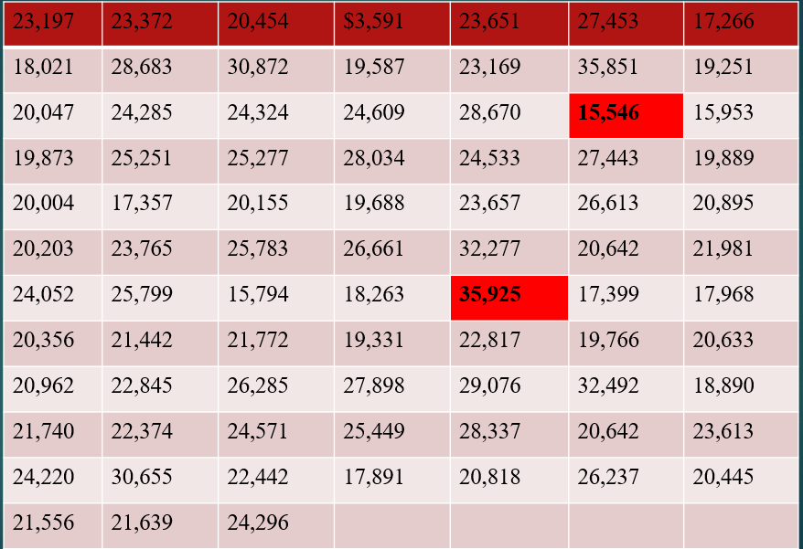
- Suppose we want to summarize last month’s sales using selling price/ we want to determine the value around which the selling price tend to cluster-
- The data presented in table is raw because it is unprocessed by statistical methods (Any information before it is arranged and analysed is called raw data)
- For the purpose of organizing and summarization, we can start with frequency distribution.

Frequency Distribution is a grouping of data

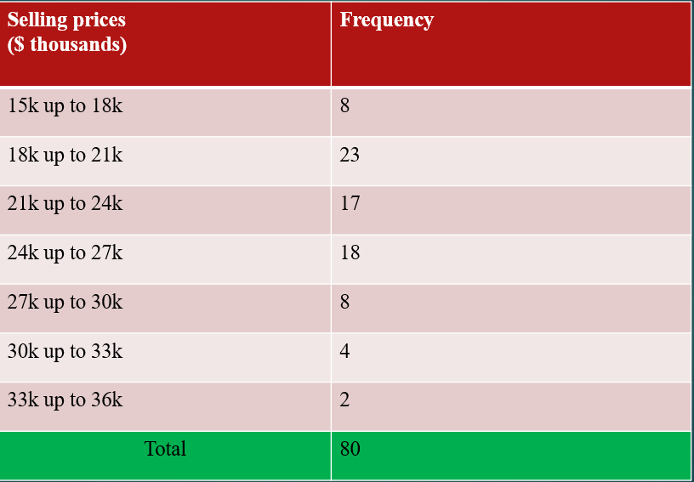

Here are some basic questions along with answers based on the frequency table you provided:
1. What is the total number of observations?
- Answer: The total number of observations is 80.
2. Which selling price range has the highest frequency?
- Answer: The selling price range 18k up to 21k has the highest frequency with 23 observations.
3. Which selling price range has the lowest frequency?
- Answer: The selling price range 33k up to 36k has the lowest frequency with 2 observations.
4. How many houses were sold for less than 21k?
- Answer: The number of houses sold for less than 21k is 8 (15k up to 18k) + 23 (18k up to 21k) = 31.
5. What is the cumulative frequency of houses sold up to 27k?
- Answer: The cumulative frequency up to 27k is 8 (15k up to 18k) + 23 (18k up to 21k) + 17 (21k up to 24k) + 18 (24k up to 27k) = 66.
6. What percentage of houses were sold in the 24k up to 27k range?
- Answer: The percentage of houses sold in the 24k up to 27k range is $\frac{18}{80}$ × 100
7. Calculate the midpoint of the 21k up to 24k selling price range.
- Answer: The midpoint of the 21k up to 24k range is $\frac{21k+24k}{2}$ =22.5k

8. What is the range of the selling prices?
- Answer: The range of the selling prices is 36k -15k = 21k
9. If you wanted to visualize this data, which type of graph would be most appropriate?
- Answer: A histogram or a bar chart would be most appropriate to visualize this frequency data.

Central tendency
Central tendency refers to the measure that identifies the center of a dataset, providing a single value that summarizes the entire data set. It gives an idea of what a typical value might be.
What is Central Tendency? - Average
Central tendency is commonly referred to as the average. It is a way of finding the center point of a dataset and helps summarize data with a single representative value.
4. Three Types of Averages
There are three main types of averages used to measure central tendency:
1. Mean:
- Definition: The mean is the sum of all values in a dataset divided by the number of values. It is the most commonly used measure of central tendency.
Median:
- Definition: The median is the middle value in a dataset when the values are arranged in ascending or descending order. If there is an even number of values, the median is the average of the two middle numbers.
- Example:
For a dataset [5, 10, 15]:
  - The Median is 10 (the middle value).
For a dataset [5, 10, 15, 20]:
  - The Median is (10+15)/2=12.5(10 + 15) / 2 = 12.5(10+15)/2=12.5 (the average of the two middle values).
3. Mode:
- Definition: The mode is the value that occurs most frequently in a dataset. A dataset can have one mode (unimodal), more than one mode (bimodal or multimodal), or no mode at all if all values are unique.
- Example:
For a dataset [5, 10, 10, 15]:
  - The Mode is 10 (as it appears more frequently than other numbers).
Central Tendency and Variability
Central Tendency and Variability are two fundamental concepts in statistics that describe the characteristics of a dataset.
Central Tendency:
Central tendency uses a single value to describe the most representative score in a dataset. This single value (like the mean, median, or mode) shows where the center of the data lies.
Variability:
Variability is the measure of how spread out or dispersed the scores in a dataset are. It gives information about how similar or different the scores are from each other.
Ways of Expressing Variability:
- Range:
  - Definition: The range is the difference between the maximum (largest) and minimum (smallest) values in a dataset. It gives a quick snapshot of the spread of the data.
  - Formula:
Range= Maximum value – Minimum Value
- Variance:
- Definition: Variance measures how far each data point in the set is from the mean (average) and thus from every other data point. It gives an average of the squared differences from the mean.
- Standard Deviation:
- Definition: The standard deviation is the square root of the variance and represents the average amount of variability or spread in the dataset. It is in the same unit as the data, making it easier to interpret.

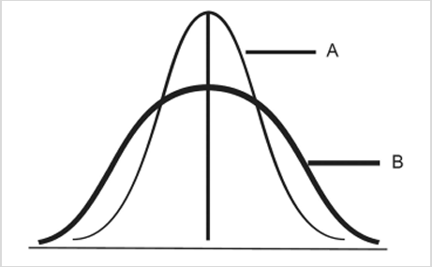
The graph you provided appears to show two different distributions, labeled A and B, on the same set of axes. Here’s what can be inferred from the graph:
- Central Tendency:
  - Both curves appear to have the same central tendency (mean or median), as they are centered around the same point on the x-axis. This suggests that the average or typical value in both distributions is similar.
- Variability:
  - Curve A is taller and narrower compared to Curve B. This indicates that the values in distribution A are more closely clustered around the mean, resulting in lower variability.
  - Curve B is shorter and wider, which suggests that the values in distribution B are more spread out, resulting in higher variability.
Business Interpretation:
- Consistency vs. Diversity:
  - Curve A represents a scenario where data points (e.g., employee performance, product quality, etc.) are very consistent. In business terms, this could mean that employees are performing very similarly, with little variation in their performance.
  - Curve B represents a scenario where there is more diversity in the data points. In a business context, this might indicate that there is significant variability in performance or quality.
- Risk and Decision Making:
  - If a company values consistency and predictability (e.g., in product quality), it would prefer a situation represented by Curve A.
  - However, if innovation and variability (e.g., in creative performance or sales) are more important, Curve B might be more desirable.
Understanding these differences helps in making informed decisions about resource allocation, employee development, quality control, and other business processes.

Example: Scenario: Quality Control in Manufacturing
You are part of the quality control team in a company that manufactures metal rods used in construction. To ensure that the rods meet the required standards, you need to assess the consistency of their lengths.
You randomly select 10 rods from a production batch and measure their lengths (in centimeters):
Rod | Length(cm)
1 | 99.8
2 | 100.2
3 | 99.7
4 | 100.1
5 | 100
6 | 100.3
7 | 99.9
8 | 100.4
9 | 99.6
10 | 100
Task:
- Calculate the Mean Length of the rods to determine the average length in this sample.
- Calculate the Standard Deviation to understand how much the lengths vary from the mean, which helps assess the consistency of the manufacturing process.
Expected Outcome:
- The mean will give you the average rod length in this sample, which should be close to the target length (e.g., 100 cm).
- The standard deviation will indicate how much individual rod lengths deviate from the average length. A small standard deviation suggests the manufacturing process is consistent, while a large standard deviation may indicate variability that could affect product quality.

Example: Calculate the mean, variance, and standard deviation for the given data set. comment what does standard deviation tells us
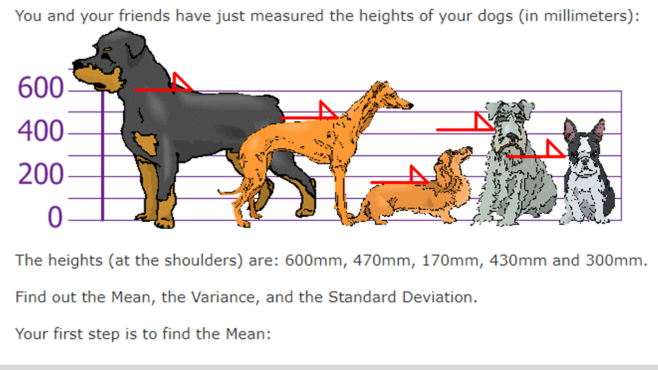
1. Mean (Average):
The mean is calculated by summing all the values and dividing by the number of observations.
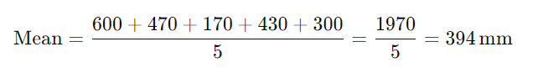
2. Variance:
Variance measures the spread of the data points from the mean. It's the average of the squared differences from the mean.
Calculating each squared difference:
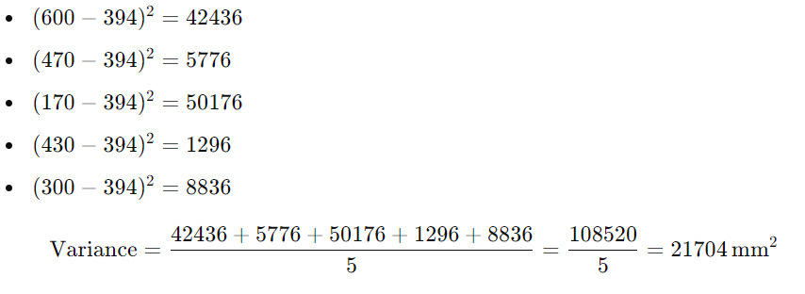
3. Standard Deviation:
The standard deviation is the square root of the variance, representing how much the data points deviate from the mean.
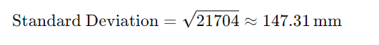
Comparison and Comment:
- Mean (394 mm): The mean height gives an idea of the central tendency of the dog heights. It indicates that, on average, the dogs' height at the shoulders is around 394 mm.
- Standard Deviation (147.31 mm): The standard deviation measures the extent to which the heights deviate from the mean. A standard deviation of 147.31 mm is relatively high, indicating that the heights of the dogs vary significantly around the mean.
Conclusion: The large standard deviation compared to the mean suggests that the dogs have a wide range of heights, with some being much taller or shorter than the average height. This indicates a diverse group of dogs with varying shoulder heights.

Calculate variance and standard deviation
What are the variance and standard deviation of each data set? •
data set 1: 3, 4, 4, 5, 6, 8
data set 2: 1, 2, 4, 5, 7, 11.
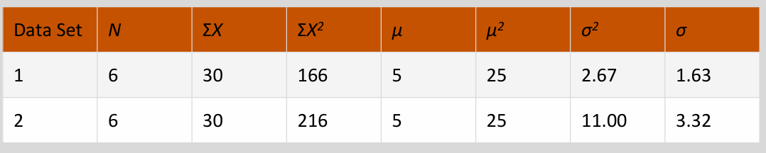
The example provided in the image shows the calculation of variance (σ²) and standard deviation (σ) for two different data sets. Here’s a breakdown of what is done:
1. Data Sets:
- Data Set 1: 3, 4, 4, 5, 6, 8
- Data Set 2: 1, 2, 4, 5, 7, 11
2. Basic Calculations:
- N: The number of data points in each set.
  - For both data sets, N=6.
- ΣX: The sum of all data points.
  - For both data sets, ΣX=30
- ΣX²: The sum of the squares of each data point.
  - For Data Set 1, Σ$x^{2}$=166
  - For Data Set 2, Σ$x^{2}$=216
- μ (mean): The average of the data points.
  - For both data sets, μ= $\frac{Σx}{N}$=$\frac{30}{6}$=5
- μ²: The square of the mean.
  - For both data sets, $μ^{2}$=25
3. Variance (σ²):
The variance is calculated using the formula:

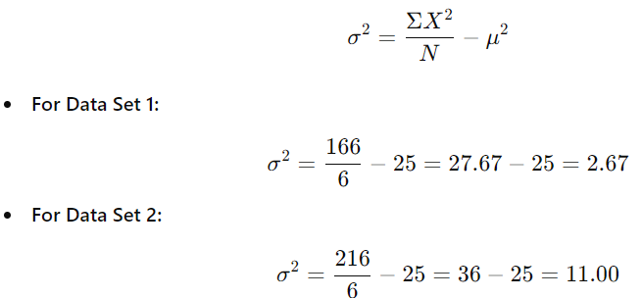

4. Standard Deviation (σ):
The standard deviation is the square root of the variance:
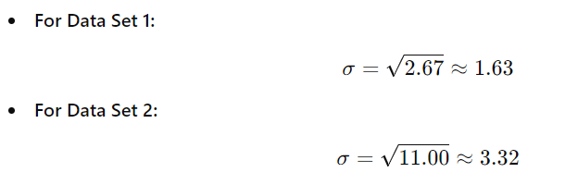
5. Graphs:
- The image also includes bar graphs that visually represent the distribution of the data points in each data set.
- Data Set 1: The bar graph shows the number of plants (y-axis) corresponding to the number of leaves per plant (x-axis). The variance and standard deviation values are also displayed.
- Data Set 2: Similarly, the bar graph represents the distribution for the second data set, along with the calculated variance and standard deviation.
Conclusion:
The example illustrates how variance and standard deviation can quantify the spread of data points around the mean. Although both data sets have the same mean (5), Data Set 2 has a higher variance and standard deviation, indicating that its data points are more spread out compared to Data Set 1.

Z-score
Given in PPT

